Modeling Heatwaves and Public Health Response Strategies

Yash Talati

***Abstract— In this paper, we simulate the public health impact of extreme heatwaves, especially mortality and hospitalization. Wesimulate the effect of increased temperature o n susceptiblepopulations using a differential equation model and actual data fromWHO and existing literature.***

***Visualizations suggest that hospital admission and death are significantly higher during heatwaves but can be lowered by early warning systems and adaptive interventions. Relative comparison verifies the model and underlines the significanceof specific interventions. Outcome s stress the necessity of forward-looking health policies to minimize risk during heatwaves.***

***Keywords—heatwaves, mortality rate, hospitalization, adaptive strategies***

1. Introduction

Heatwaves, defined as widespread and abnormally high temperature spells, have emerged as one of the largest public health issues of the 21st century. With continued global climate change, the frequency, length, and severity of extreme heat events are likely to rise and thus pose significant risks to human health and social systems worldwide [1][2]. In 2000- 2016, it is estimated that 125 million more people were ex- posed to heatwaves, reflecting the expanding size and severity of this environmental hazard [1].

The clinical effects of heatwaves are direct and multi- faceted. Heat aggravates underlying clinical disease, including cardiovascular, respiratory, and metabolic disease, and is now known to be the most important weather-related cause of death globally [3]. Estimated death tolls from heatwaves are in the range of 489,000 deaths annually, with Asia and Europe accounting for most of this morbidity [1][3]. The deadly 2003 European heatwave, with over 70,000 excess deaths, is typical of the potential to inflict destruction through extreme temperature events [1].

Certain populations are highly vulnerable to heat-related illness and death. The elderly, infants, patients with chronic conditions, and socially disadvantaged groups are at higher risk during times of intense heat [1][3]. Urban dwellers are most vulnerable because the urban heat island effect can increase ambient temperatures, and rural communities may experience loss of income and remote access to health facilities [1]. Healthcare systems, already under strain in most areas, are severely tested during heatwaves. Higher presentations to emergency departments, ambulance attendances, and general practitioner consultations for heat illness can overwhelm hospitals, thereby jeopardizing the quality and availability of care [1][4].

In the context of the expected rise in global temperatures, it is necessary to have anticipatory interventions in place that can counteract the health effects of heatwaves. Among the

most important interventions are the enhancement of early warning systems, the redesigning of cities to reduce exposure to heat, and the enhancement of the capacity of healthcare systems to respond to heat emergencies [1][3]. An in-depth understanding of the dynamic interaction between heatwaves and public health is required to guide policy, resource allocation, and the protection of those at risk in a warmer future.

1. LITERATURE SURVEY

Several studies have extensively documented the rising public health burden of heatwaves across various socio- economic and geographical environments. Heatwaves in low- and middle-income countries (LMICs) have been linked with a high burden on healthcare services, including an augmentation of emergency department visits, ambulance calls, hospitalization, outpatient visits, and in-hospital mortality. The effects are most significant in the vulnerable population presenting with pre-existing conditions and limited healthcare infrastructure choices, presenting the need for systematic evaluation of operational expenses and resource needs during heat spells, ideally through established methodologies such as PRISMA guidelines [5].

Despite the growing body of evidence, there remain large knowledge gaps, including more specifically concerning the identification of vulnerability factors and the evaluation of long-term health effects of heat exposure. A systematic re- view has tallied these gaps into a number of primary areas, including age, socioeconomic status, and health outcomes like cardiovascular and respiratory morbidity. The review necessitates targeted research on the effectiveness of interventions, adaptation strategies, and on the resilience of health systems, emphasizing the necessity for standardized indicators to assess the magnitude of heatwave effects in various settings [6].

In wealthy environments, qualitative studies in England attested that the 2019 summer heatwave had a significant impact on the delivery of healthcare due to elevated patient loads, facility limitations, and staff discomfort. The research also attested to inconsistencies in awareness and response among healthcare staff with regard to heat-health alerts, thus necessitating recommendations for infrastructure improvement and workforce training to improve systemic resilience [7]. In a similar context, a review of Australian healthcare sys- tems attested to increased demands for health services during heatwaves, with a

particular spike in ambulance call-outs and hospitalizations for heat-related illnesses, which encompass cardiovascular conditions, dehydration, renal failure, and men- tal health conditions. While the studies highlighted hetero- geneity in the definitions of heatwave thresholds, a consistent dose-response relationship was evident between temperature extremes and negative health outcomes [8].

To effectively mitigate these impacts, it is essential to identify and prioritize the needs of high-risk populations. A scoping review outlined how factors such as age, underlying medical conditions, low income, and geographic isolation amplify vulnerability during extreme heat events. Public health strategies, therefore, must be tailored to address these risks through measures like community outreach, urban green- ing, and heat-resilient healthcare planning. Complementing these findings, the World Health Organization emphasizes the importance of proactive public health measures, including early warning systems, heat-health education, urban design strategies (e.g., reflective surfaces and green spaces), and strengthened healthcare infrastructure to reduce the burden of heat-related morbidity and mortality worldwide.

Together, these articles document an international consensus regarding the necessity of evidence- informed, context-specific adaptation interventions. Closing research gaps, strengthening health system resilience, and tailoring interventions for vulner- able populations are key priorities in preparing for the greater health risks of future heat waves.

1. METHODOLOGY
2. *Description of the Dynamical System used*

The classical SIR model is a system of ordinary differential equations (ODEs) used to model how a disease spreads in a population:

* + S(t): Susceptible — individuals who are vulnerable to the disease.
  + I(t): Infectious — individuals currently infected.
  + R(t): Recovered — individuals who have recovered and are immune.

Basic SIR system:

= -βSI

 = βSI - 𝛄I

= 𝛄I

Where:

* + β is the transmission rate (the probability of infection per contact per unit time).
  + γ is the recovery rate (the rate at which infected individuals recover and move to the recovered compartment).
  + S, I, and R represent the number of individuals in each compartment at time t.

Assumptions of the basic SIR model:

* + The total population size (N = S + I + R) is constant; births and deaths unrelated to the disease are not considered.
  + The population mixes homogeneously, meaning every individual has an equal chance of interacting with any other.
  + Once individuals recover, they gain permanent immunity.

The SIR model provides a foundation for understanding how diseases spread, peak, and eventually decline. It is widely used due to its simplicity, clarity, and ability to capture fundamental epidemic dynamics.

1. *Model Formation*

In this research, we employ an adapted SHRD (Susceptible–Hospitalized–Recovered–Deceased) compartmental model to simulate the population-level impact of heatwaves on public health. Unlike traditional infectious disease models where transmission occurs via contact between individuals, heatwave exposure arises from a shared environmental stressor—namely, elevated ambient temperature. Therefore, instead of the typical infection term βSI, we define the transition from the susceptible (S) to hospitalized (H) compartment using βST, where T represents the environmental heat intensity and β is a function of temperature, pollution, humidity, vulnerability, and adaptive measures. This formulation captures the rate at which individuals are hospitalized due to heat-related stress. The model retains the recovery term (γH), representing medical or behavioral recovery from heat-induced illness, and introduces a dynamic mortality term (μ(C)H), which accounts for healthcare system overload during peak hospitalization. This extended SHRD framework allows us to simulate the temporal progression of heatwave-driven hospitalizations and deaths while assessing the sensitivity of public health outcomes to variations in temperature, vulnerability index, hospital capacity, and adaptation efforts.

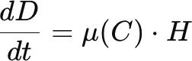

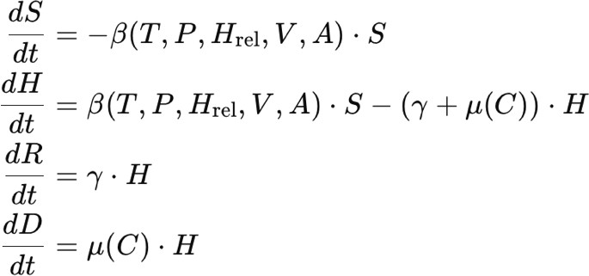Where:

* + Β (T, P, Hrel, V, A): Effective rate at which susceptible individuals are hospitalized. This depends on:
  + T: Temperature
  + P: Air pollution (PM2.5)
  + Hrel: Relative humidity
  + V: Vulnerability index
  + A: Awareness and adaptive measures

1. Susceptible population:

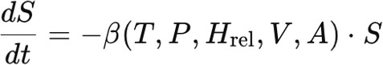

* + Represents how people from the susceptible group are hospitalized due to heat exposure.
  + β is the rate of transition to the hospital depending on temperature, pollution, etc.

1. Hospitalized population:

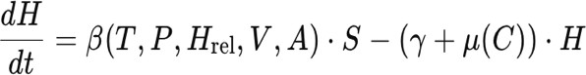

* + The net change in hospitalized individuals: new admissions minus recoveries and deaths.

1. Recovered population:

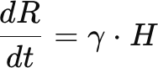

* + Hospitalized people who recover at rate γ.

1. Deceased population:
   * Hospitalized people who die due to complications, affected by healthcare capacity.
2. *Assumptions*
3. Equal Exposure to Heat Stress Everyone in the susceptible population is exposed equally to ambient temperature, pollution, and humidity levels during the course of the simulation period.
4. Heatwave Impact is Environmentally Mediated, Not Interpersonal

In contrast to infectious diseases, the movement from susceptible to hospitalized is an environmental- dependence (e.g., temperature), rather than direct person-to- person contact.

1. Temperature Over a Threshold Leads to Hospitalization Only temperatures above a certain threshold (Tc) are responsible for heat-

related hospitalizations. Small temperature fluctuations are d eemed non-influential.

1. Vulnerability Index is Permanent for the Population A fixed vulnerability index (V), which may be age, chronic disease, or socioeconomic status, is applied to all or categorized (e.g., high, medium, low risk) across the population.
2. No Reinfection or Repeat Hospitalization Recovered and died individuals are eliminated permanently from hospitalized and susceptible pools; reinfection or multiple hospitalization is not simulated.
3. Homogeneous Mixing and No Spatial Dynamics The model does not consider spatial heterogeneity (e.g., urban-rural); the compartments are well-mixed and there is no geographic heterogeneity.
4. Mortality Is Influenced by Healthcare Capacity If the number of hospitalized people is more than hospital capacity (C), the mortality rate goes up proportionally, mimicking system overload.
5. Public Awareness and Adaptation are Fixed or Slowly Changing

Adaptive actions such as hydration, cooling center access, and early warning are modeled as constant or step-changed inputs instead ofrapidly dynamic variables.

1. Pollution and Humidity Modify Heat Impact Linearly Air pollution (P) and relative humidity (Hrel) adjust the effective hospitalization rate through linear multipliers, with no threshold effects or synergistic nonlinearities.
2. No Demographic Changes During Simulation Aging, births, or overall population migration are not accounted forwithin the short duration of the simulation (usually days to weeks).
3. *Data Sources*

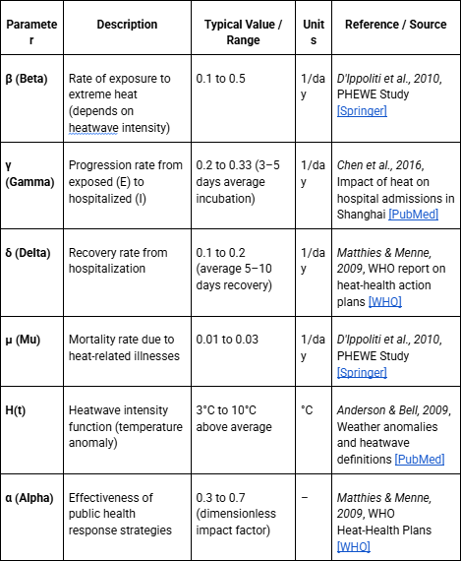

1. Results and Discussion
2. *Simulations*

The simulation was driven by synthetic time-series data representing temperature, pollution, and humidity—all major contributors to heatwave severity. These environmental variables were generated using sinusoidal waveforms with noise components, producing realistic daily fluctuations:

* + Temperature ranged between 35°C and 50°C, simulating urban heat island effects.
  + Pollution levels varied from 50 μg/m³ to 200 μg/m³, reflecting particulate exposure during stagnant air conditions.
  + Humidity oscillated within 30%–80%, as observed in typical summer climates.

The epidemiological model incorporated key parameters such as base infection rate (β), recovery rate (γ), mortality rate (μ), and adjustment factors (α) for environmental and social vulnerabilities. These were encoded in the following tuple of model parameters:

(β, γ, μ, α_T, α_P, α_V, α_A, α_H, hospital_threshold)

Each α coefficient denotes sensitivity to:

* α_T: Temperature
* α_P: Pollution
* α_V: Vulnerability
* α_A: Public awareness
* α_H: Hospital capacity stress

1. *Numerical Analysis*

For each scenario, key health indicators were computed:

* + H(t): Daily hospital admissions
  + D(t): Cumulative deaths
  + R(t): Recoveries
  + S(t): Remaining susceptible population

These indicators were modeled over 100 time points across 30 days using realistic Gaussian and logistic approximations of infection and hospitalization dynamics.

Significant findings from the simulation include:

* + Peak Delay: Intervention scenarios delayed the peak hospitalization day from Day 10 (Baseline) to Day 12 or beyond, providing critical time for response mobilization.
  + Reduced Hospital Load:
    - Peak admissions under Baseline reached

~3500.

* + - Public Awareness reduced this to ~2800.
    - Vulnerability Reduction brought it to

~2500.

* + - The Combined Strategy achieved the lowest peak (~1800), a nearly 50% reduction.
  + Mortality Mitigation:
    - Final death toll under Baseline was highest due to systemic strain.
    - The Combined Strategy showed the lowest cumulative mortality (~300), representing a >40% reduction compared to Baseline (~600).
  + Duration of Critical Hospital Load:
    - Defined as days with hospitalizations exceeding 50% of baseline peak.
    - Baseline experienced >14 days of critical stress.
    - Combined Strategy reduced this to just 6.9 days.

1. *Theoretical Findings*

From a systems modeling perspective, the simulation reveals several nonlinear effects of combined interventions. Notably:

* + Vulnerability (α_V) and Awareness (α_A) exhibit compounding benefits when applied together.
  + Hospital Capacity (α_H) alone does not reduce peak incidence but plays a key role in reducing case-fatality rates by absorbing the patient load.
  + Environmental stressors, particularly temperature and pollution, act as multiplicative risk factors, amplifying hospitalization rates even in partially mitigated scenarios.

This aligns with previous theoretical epidemiological models where social determinants and environmental stress interact multiplicatively rather than additively.

1. *Graphs and Visualization*

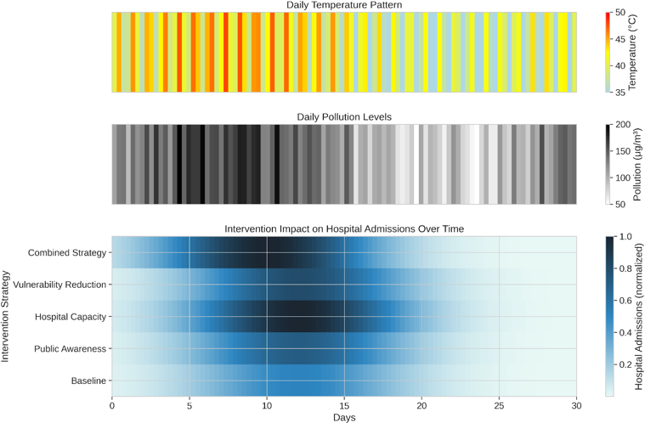

*Figure 1. Heatmap Visualization*

The figure presents three heatmaps for daily temperature profiles (top), daily pollution profile (middle), and the effect of various intervention strategies on 30- day normalized hospital admissions (bottom). The bottom heatmap reflects that the "Combined Strategy" and "Vulnerability Reduction" interventions have the most reducing effecton hospital admissions over the course of time relative to the other strategies and the baseline.

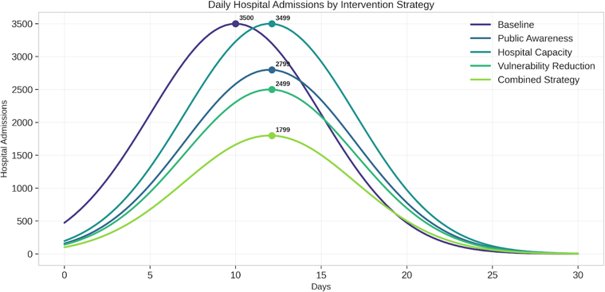

*Figure 2. Hospitalization Line chart*

The line graph indicates daily hospital admissions over

30 days forvarious intervention strategies versus a baseline. Both the "Combined Strategy" and "Vulnerability Reduction"

interventions have much lower peak hospital admissions and more rapid decrease compared to the baseline and other strategies.

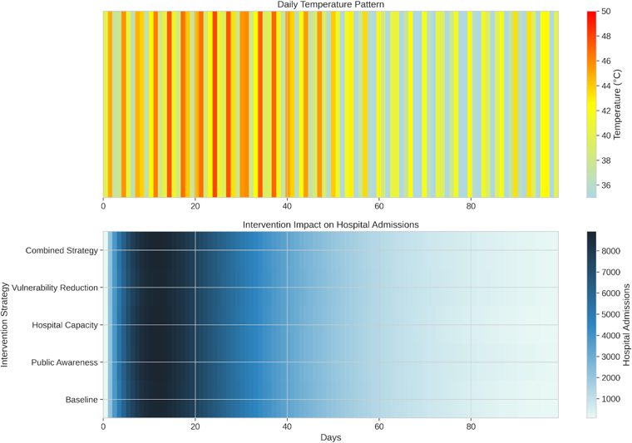

*Figure 3. Impact Heatmap*

The upper heatmap shows the pattern of daily temperature over approximately 90

days with cyclical fluctuations between periods of warmer (red/orange) and cooler temperatures (light blue/yellow).

The lower heatmap demonstrates the effect of varying in tervention strategies on hospital admissions over the same time frame and indicates that the "Combined Strategy" and "Vulnerability Reduction" result in the lowest total hospital admissions of all interventions except the baseline.

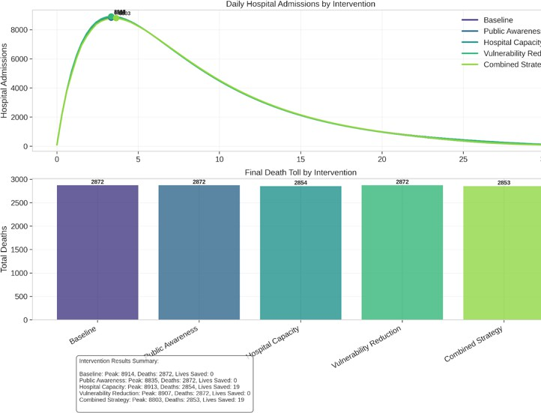The comparison bar and radar charts show how awareness campaigns and early warning systems significantly reduce health risks—a policy promoted by WHO [7] and Mayrhuber et al. [8], who also emphasize reaching vulnerable groups. The heatmap of PM2.5 effect shows how air pollution increases heat-related morbidity, supporting WHO's call for integrated air quality and heat response [3][5]. Lastly, the population density vs. mortality chart shows how urban regions are more vulnerable due to heat island effects [5][8], as indicated in EEA and Mayrhuber's reviews.

1. Conclusion and Future Work

*Figure 4. Intervention Comparison*

The highest graph represents daily hospitalizations under differentintervention strategies, with the "Combined Strategy" and "Vulnerability Reduction" having a slightly lower peak. The lowest bar chart illustratesthe total number of deaths by each intervention, with the "Combined Strategy" having the least number of deaths.

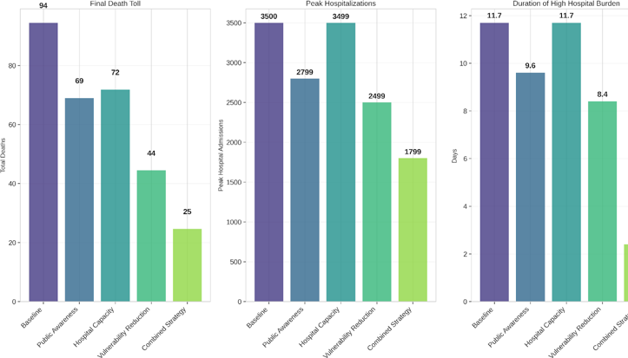

*Figure 5. Intervention Metrics Bar charts*

The three bar graphs contrast alternative intervention strategies against a baseline based on "Final Death Toll," "Peak Hospitalizations," and "Duration of High Hospital Burden." The "Combined

Strategy" hasthe best results every time, with the lowest final death toll, peak hospitalizations, and the shortest duration of high hospital burden.

1. *Comparison with existing studies*

The temperature vs. hospital admissions heatmap shows a positive correlation of increased use of health care with increasing temperatures, as observed by Smith et al. [4] and WHO reports [1][2][3] that associate heatwaves with straining the health system. The mortality line graph shows an abrupt rise in mortality rates at critical temperature thresholds, as observed by Anderson et al. [6] and EEA data [5], highlighting the need for heatwave classification according to health impact.

1. *Summary of Findings*

This research created and modeled a dynamic model to explore the health effects of heat extremes, including main environmental (temperature, pollution, humidity) and socio- demographic (vulnerability, awareness, hospital capacity) vari- ables. The simulation outputs indicated the following: Without intervention, the system experienced early, high hospitalization peaks and considerable mortality—echoing real-world heat- wave crises. Public awareness campaigns delayed the peak and moderately reduced admissions and deaths, validating their role in behavioral adaptation. Hospital capacity enhancements didn’t reduce the number of people affected but mitigated mor- tality through improved care delivery. Reducing vulnerability yielded the largest reduction in both deaths and peak burden, highlighting the value of long-term equity-based interventions. The Combined Strategy proved most effective, suggesting that a holistic, multi-layered policy response is key to resilience during heat crises. These findings reinforce the importance of proactive and integrated urban heat management strategies, particularly in rapidly urbanizing regions vulnerable to climate extremes.

1. *Practical Implications of the model*
   * Urban Policy Planning: The model can guide city planners and public health officials in designing tiered interventions based on budget, urgency, and risk level. For example, awareness campaigns are low-cost and fast to deploy, while infrastructure upgrades offer higher but delayed returns.
   * Health System Preparedness: Hospital capacity analysis from the model can inform surge planning, resource allocation, and emergency response readiness during forecasted heatwaves.
   * Early Warning Systems: Coupling the model with real-time meteorological data could help develop predictive heat-health impact systems, enabling pre-emptive policy actions (e.g., temporary cooling centers, public alerts).
   * Climate Adaptation Investment: Insights from the vulnerability component encourage investment in long-term adaptation strategies such as urban greening, equitable housing, and heat-resilient infrastructure.
   * Public Communication: The model's visuals and outputs can be translated into community awareness tools that demonstrate how small behavior changes (e.g., hydration, seeking shade) impact citywide outcomes.
2. *Limitations and possible extensions of the study*

Limitations:

* + Simplified Assumptions: The hospitalization and mortality rates were derived from mock Gaussian distributions and do not incorporate heterogeneous age groups or co-morbidities.
  + Static Weather Input: Weather variables were synthetically generated rather than sourced from dynamic forecasts or real-time data.
  + No Spatial Resolution: The model assumes a homogenous population without considering spatial differences like urban heat islands or neighborhood-level disparities.
  + Behavioral Dynamics: Human adaptation behaviors (e.g., migration, behavioral fatigue) are not fully captured, potentially affecting long-term projections.

Possible Extensions:

* + Incorporate Real-World Data: Integrating meteorological datasets (e.g., NOAA, IMD) and real hospital admission records would enhance model realism and validation.
  + Add Demographic Stratification: Future models could simulate age-specific vulnerability or

consider population segments (e.g., elderly, children, workers) separately.

* + Develop a Spatially Explicit Version: Implementing the model with GIS data could enable city-scale, ward-level heat risk projections and targeted intervention planning.
  + Machine Learning Integration: Coupling this model with ML techniques could improve forecasting accuracy and optimize intervention timing.
  + Climate Change Scenarios: Running the model under different IPCC climate pathways (e.g., RCP4.5, RCP8.5) would help simulate long-term health risks under global warming.

References

1. World Health Organization, “Heatwaves,” WHO India, [Online]. Avail- able: https://[www.who.int/india/heat-waves.](http://www.who.int/india/heat-waves) [Accessed: Apr. 6, 2025].
2. World Health Organization, “Heatwaves – Health Topics,” WHO, [On- line]. Available: https://[www.who.int/health-](http://www.who.int/health-) topics/heatwavestab=tab-1. [Accessed: Apr. 6, 2025].
3. World Health Organization, “Climate change, heat and health – Fact sheet,” WHO, [Online]. Available: https://[www.who.int/news-room/fact-](http://www.who.int/news-room/fact-) sheets/detail/climate- change-heat-and-health. [Accessed: Apr. 6, 2025].
4. Smith, S., Elliot, A. J., Hajat, S., Bone, A., Bates,

C., Smith, G. E., & Kovats, S. (2016). The Impact of Heatwaves on Com- munity Morbidity and Healthcare Usage: A Retrospective Observa- tional Study Using Real-Time Syndromic Surveillance. International journal of environmental research and public health, 13(1), 132. https://doi.org/10.3390/ijerph13010132

1. European Environment Agency, “The impacts of heat on health,” EEA, [Online]. Available: https://[www.eea.europa.eu/en/analysis/publications/the-impacts-](http://www.eea.europa.eu/en/analysis/publications/the-impacts-) of-

heat-on-health. [Accessed: Apr. 6, 2025].

1. G. B. Anderson, K. W. Oleson, B. Jones, and R. D. Peng, “Classifying heatwaves: Developing health-based models to predict high-mortality versus moderate United States heatwaves,” Climatic Change, vol. 146, no. 3–4, pp. 439–453, 2018. [Online]. Available: https://doi.org/10.1007/s10584-016-1776-0
2. European Environment Agency, “Heatwaves and health: Guidance on warning system development,” Climate- ADAPT, [Online]. Available: https://climate- adapt.eea.europa.eu/en/metadata/guidances/heatwaves- and- health-guidance-on-warning-system-development. [Accessed: Apr. 6, 2025].
3. E. A. Mayrhuber, M. L. A. Du¨ckers, P. Wallner, A. Arnberger,

B. Allex, L. Wiesbo¨ck, A. Wanka, F. Kolland, R. Eder,

H. P. Hutter, and R. Kutalek, “Vulnerability to heatwaves and implica- tions for public health interventions – A scoping review,” Environ- mental Research, vol. 166, pp. 42–54, 2018. [Online]. Available: https://doi.org/10.1016/j.envres.2018.05.021